**JAVA WEB FUNDAMENTALS**

# INTRODUCTION

## What is the web application

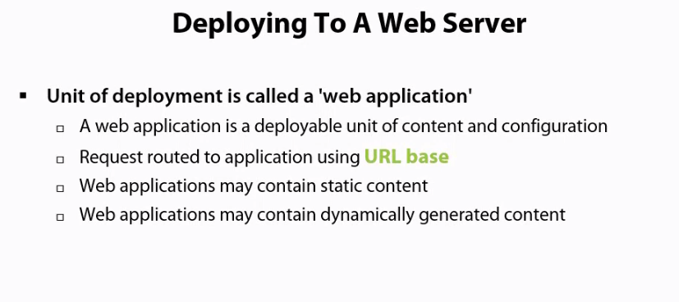

## Tom cat is manager application

Maven make deployment easier, maven can both create .war file to allow us to deyploy, and then copy those .war file into the appropriate directory

## Strust is a servlet and javasever page framework

# WRITING SERVLETS

## The base servlet interfaces and classes

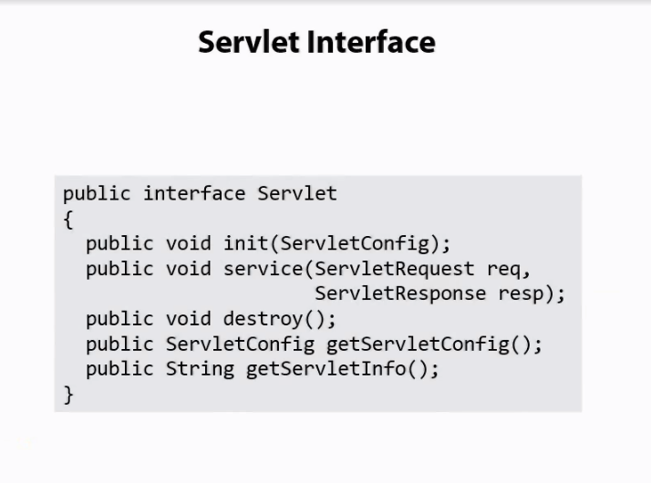

Provide configuration

Information for the servlet which is passed through the web.xml file

## Writing for first servlet

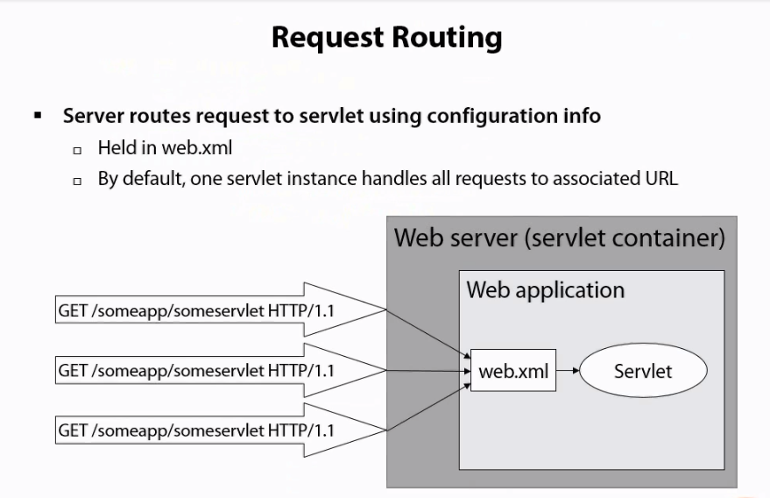

## Reading an HTTP request and generate a response

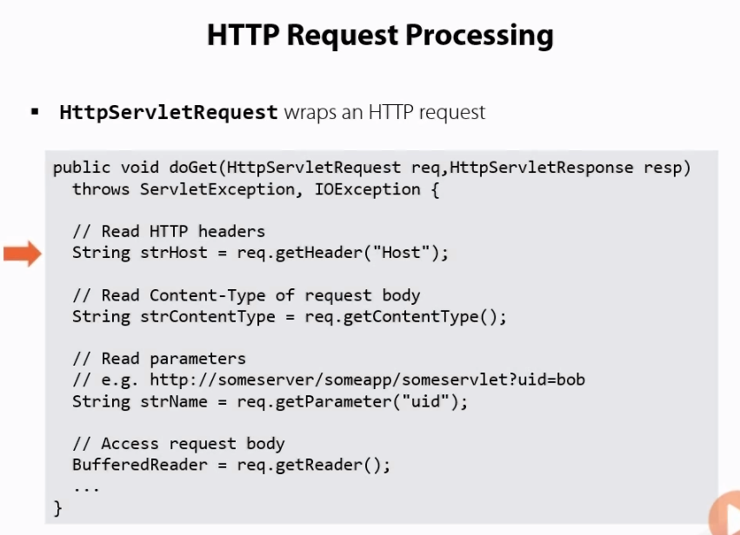

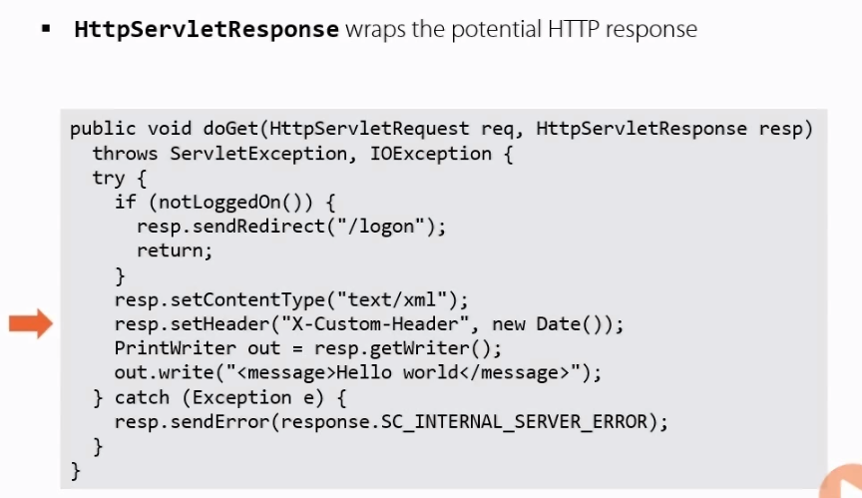

## Initializing a Servlet

Get parameter

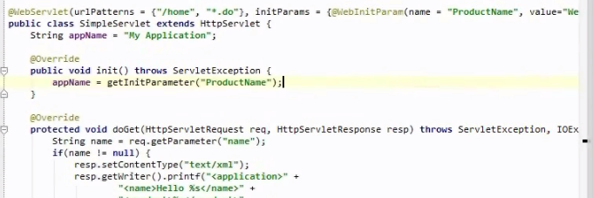

**JAVASERVER PAGES**

## Using Directives

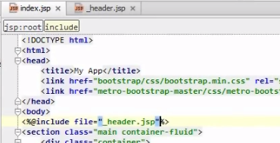

## Handling errors

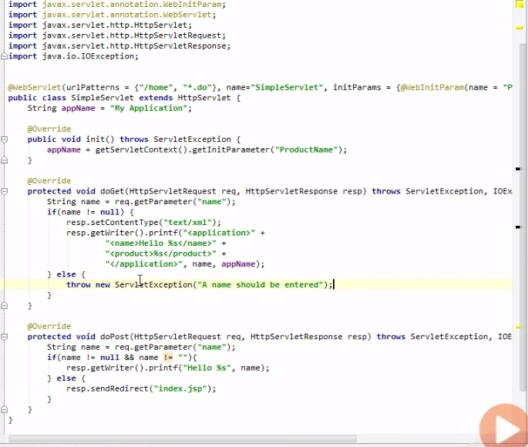

Result

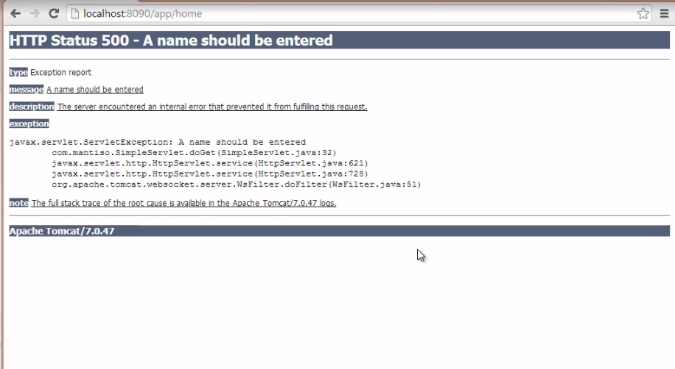

Fix

Create errorpage.jsp and declare in web.xml

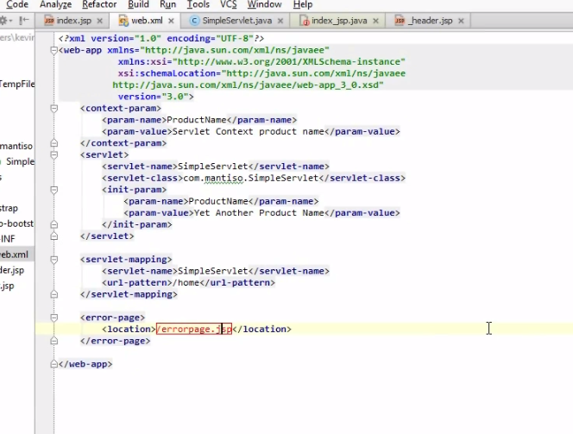

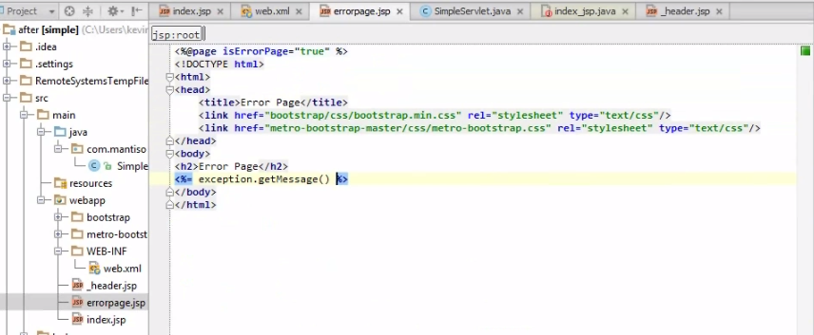

Print massage from doGet (else..)

Result

## Model view controller in a java web application

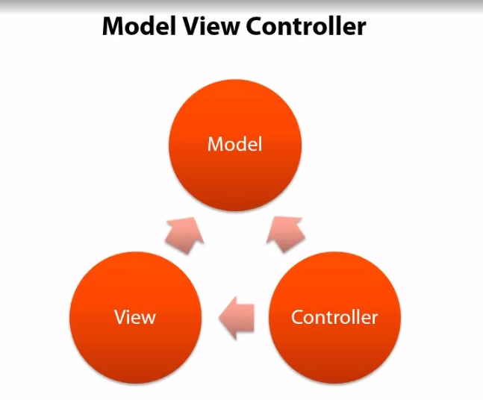

* Model which is the data we’d like to display
* The view which is the place where ew display the data , and the view could be (XML, JSON , HTML )
* Controller bring the view and Model together

Controller in web applicaton will receive incoming requests generate some data , which will be the model , and then pass that data off to the view

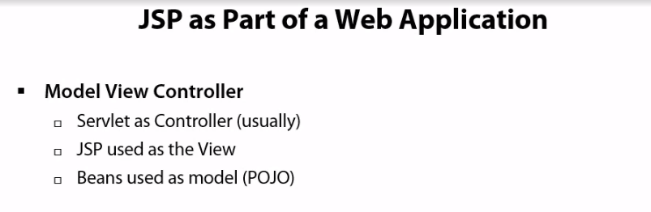

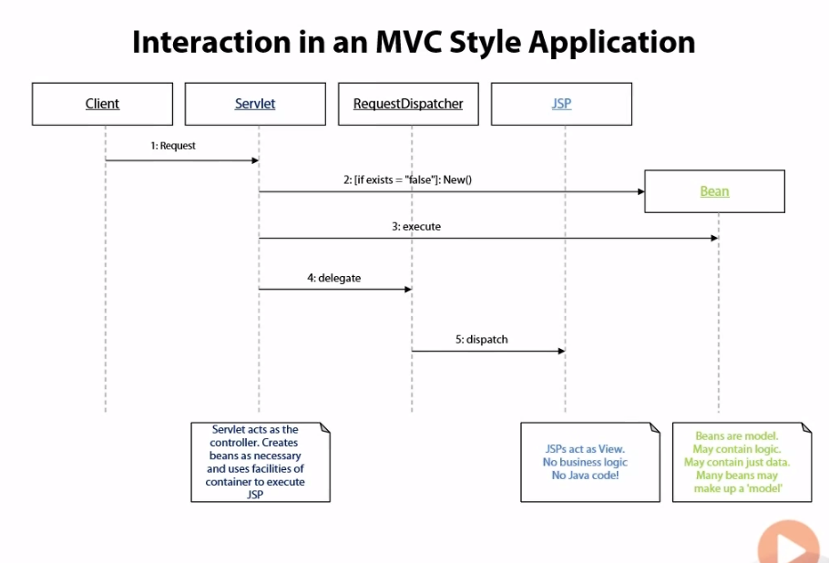

Pass the bean into jsp

Access object is call RequestDispatcher to take current request dispatch it to some other servlet

Sevlet call method on the bean

The first thing Sevlet create bean, if bean already exist it get bean form some local storage

Need to Pass the request onto the jsp, and use the jsp to display this data to do that we use something called a RequestDispatcher

When has dispatcher, we send the request off to the jsp and the code

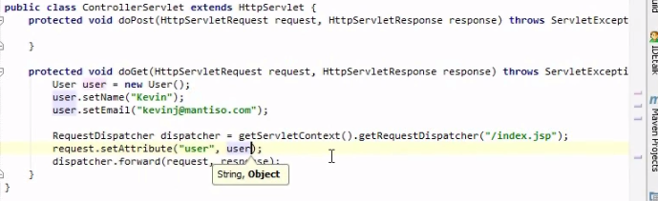

Get the bean on to the page

Place object on global scope

Save this in a variable

Pass request onto the jsp and use jsp display data

get the bean from the attribute

Use scriptlet

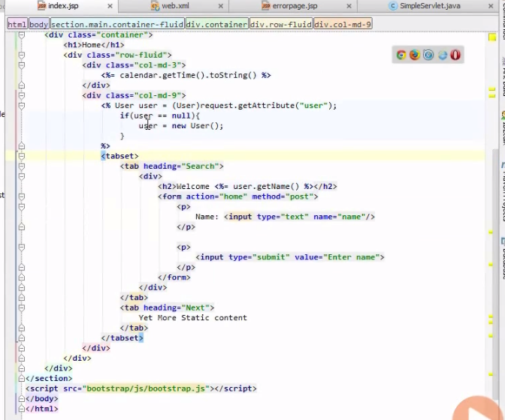

Result

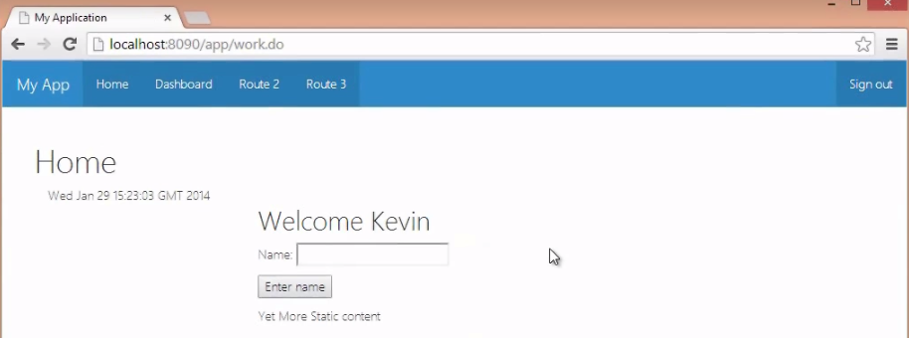

# THE EXPRESSION LANGUAGE

Give us access to properties on java bean , and we can use those to display data on the page

## Using the expression language

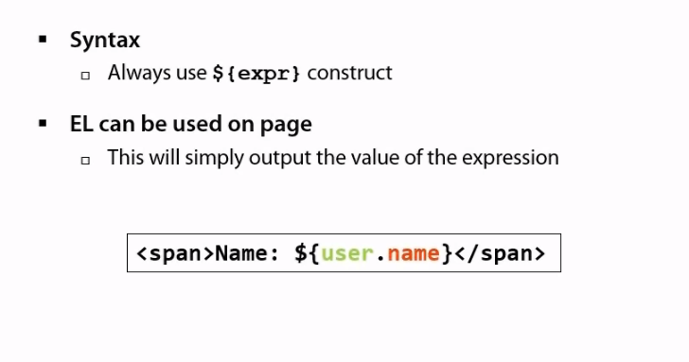

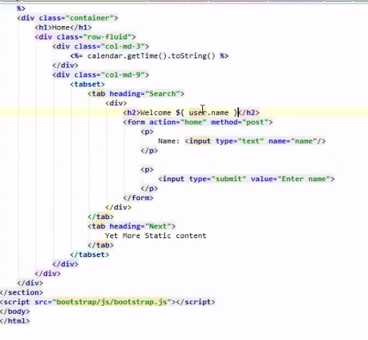

Use expression language

Result



## We have class ApplicationSettings

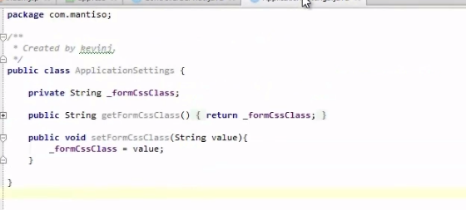

Set in servlet

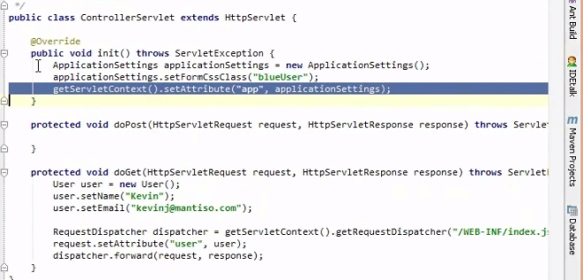

Class blueUser

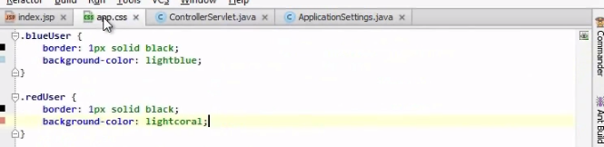

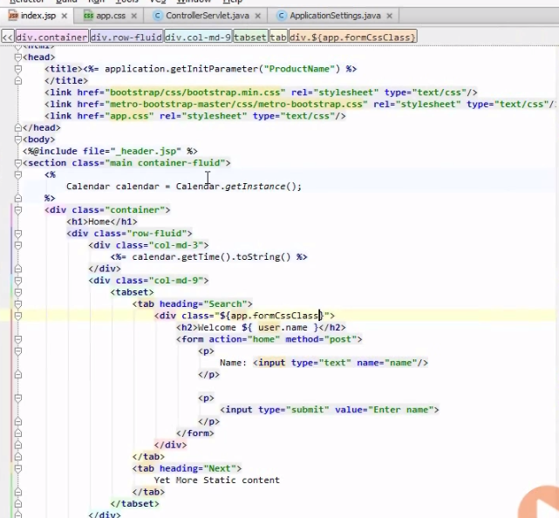Get it in jsp

Result

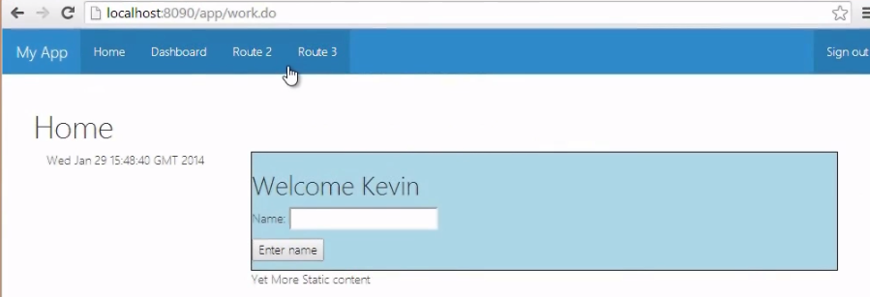

## Making use of JavaBeans

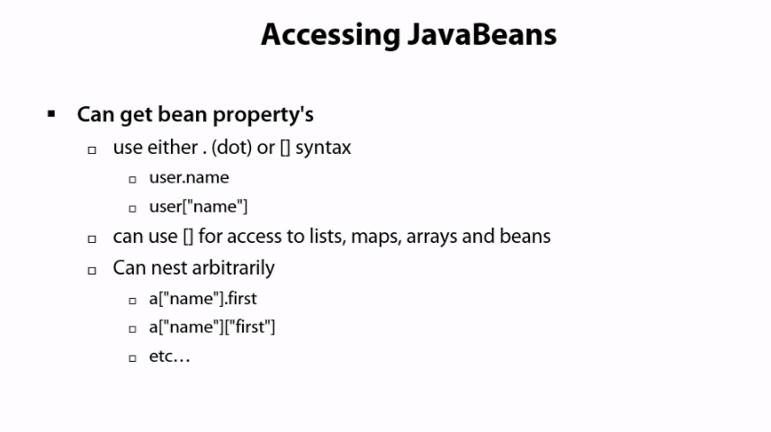

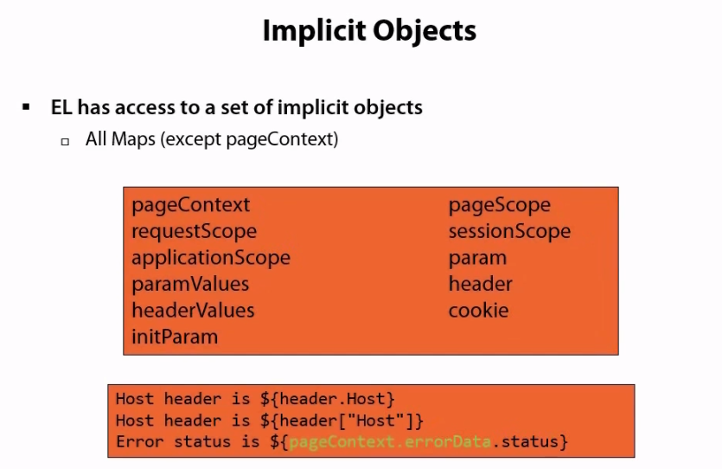

In file applicationsetting

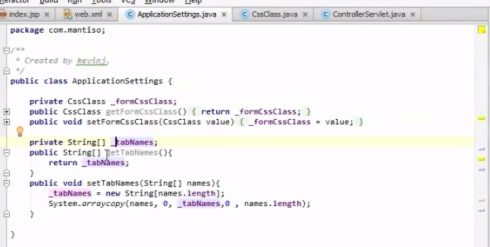

In file servlet

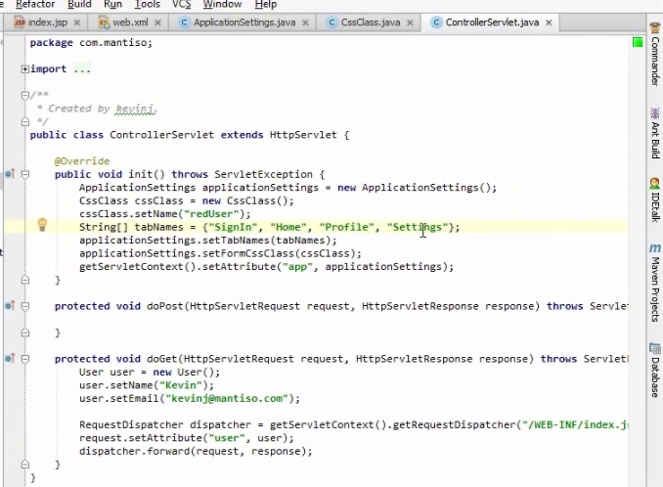

In file jsp

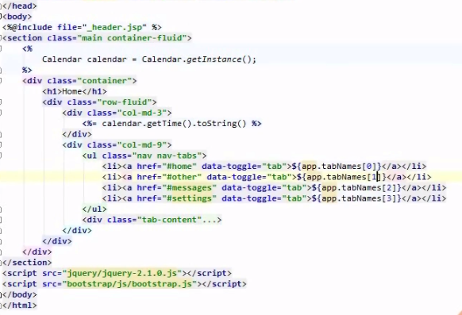

Result

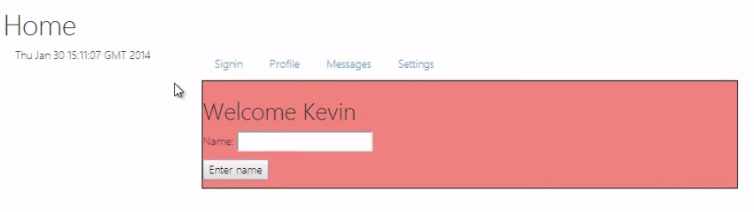

## Using operator in expression language(EL)

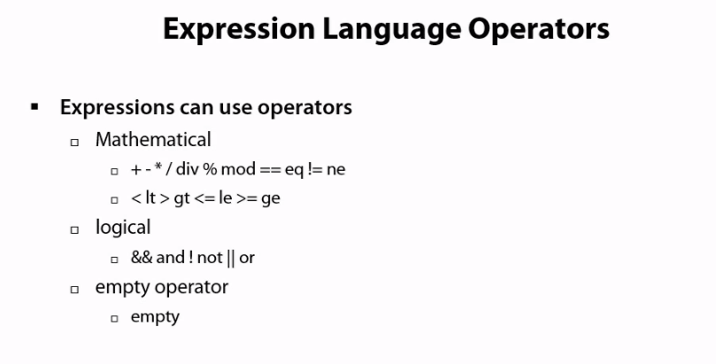

# THE JAVA STANDARD TAG LIBRARY

## Using the conditional tags

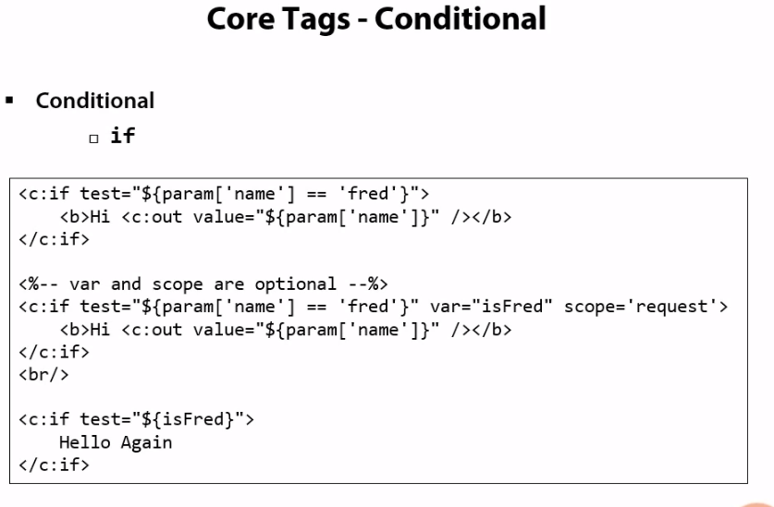

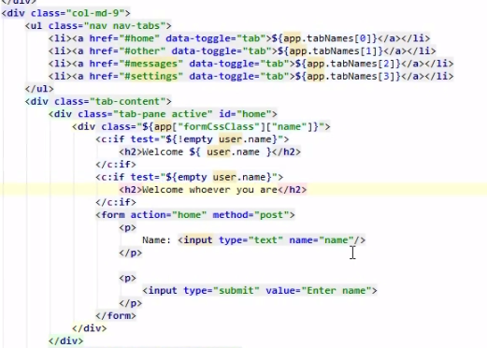

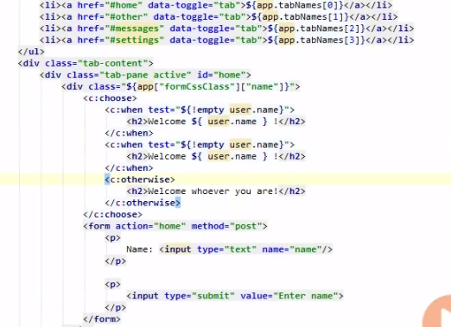

## Looping with the iteration tags

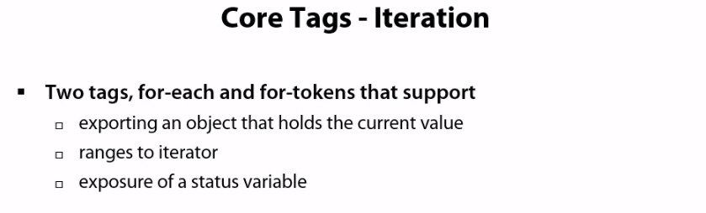

Class ApplicationSetting

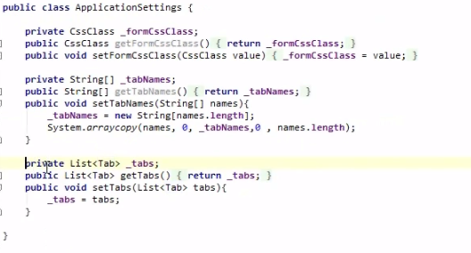

Inside ControllerServlet

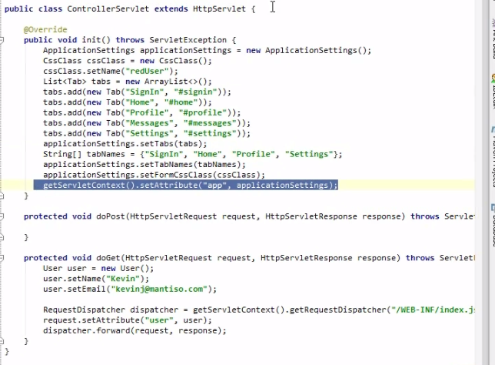

Inside file index.jsp

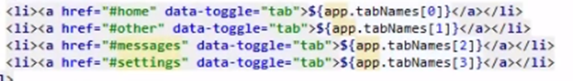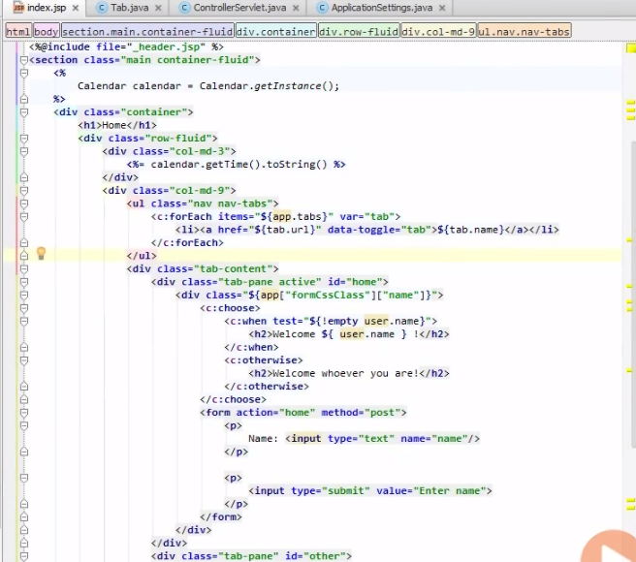

instead

Result

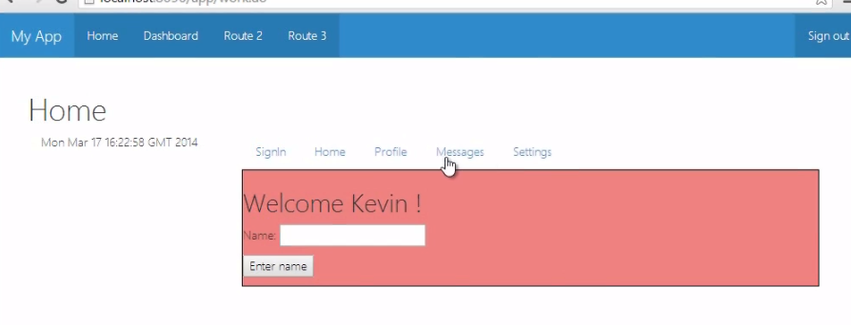

## Import data and the URL Tag

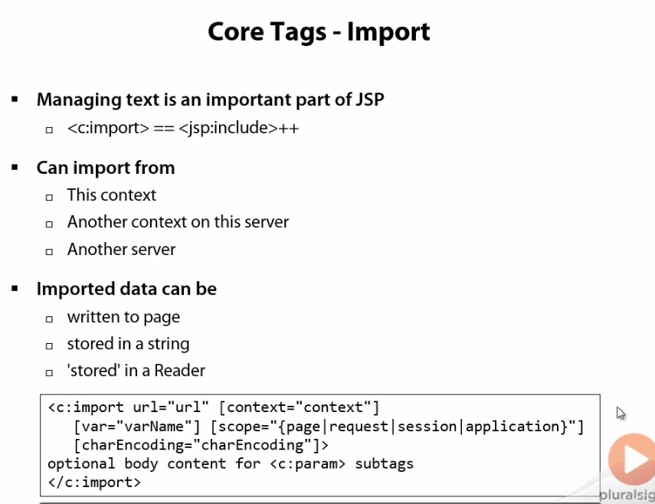

Reuse url

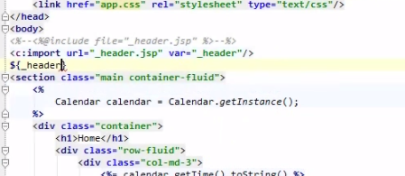

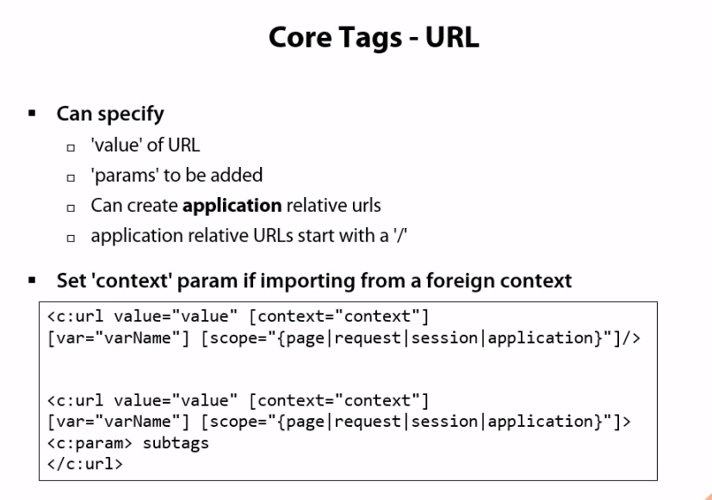

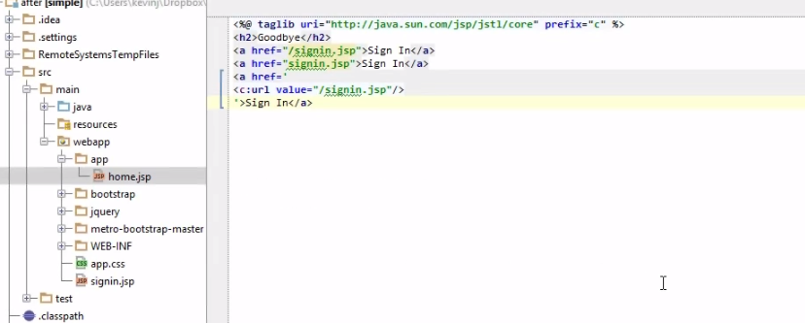

3

2

1

* url 1: relative to the root of the server
* url 2: relative to the root of this particular page (app/app/signin.jsp)
* url3: relative to the root of this application (/app/signin.jsp)

result

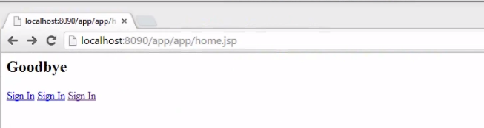

Click 1:

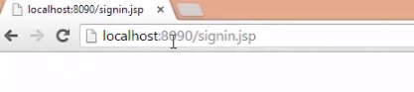

Click 2

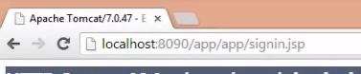

Click 3

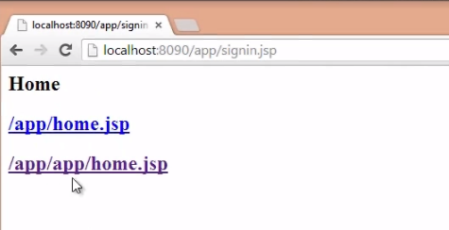

# WRITING TAG LIBRARIES

## writing tags in tag files

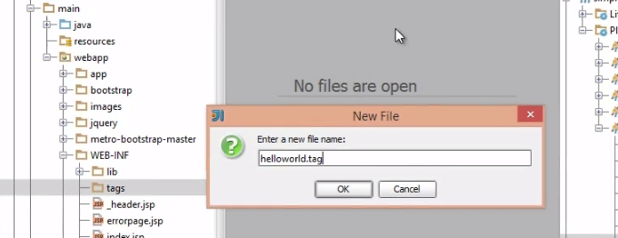create tag folder and helloworld.tag

in file helloworld.tag

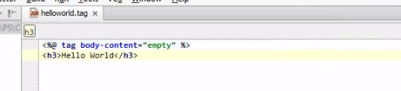

declare it in index.html

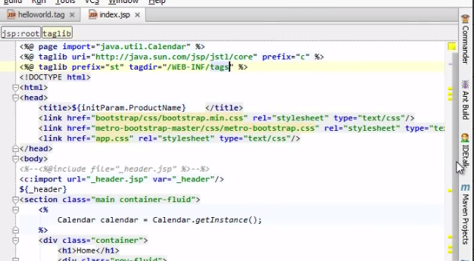

Call it

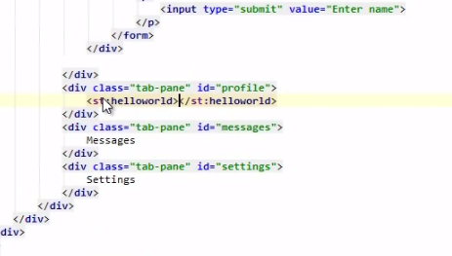

Result

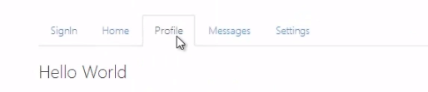

Adjust file helloworld.tag having attribute

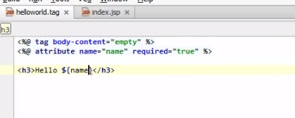

In file index.html

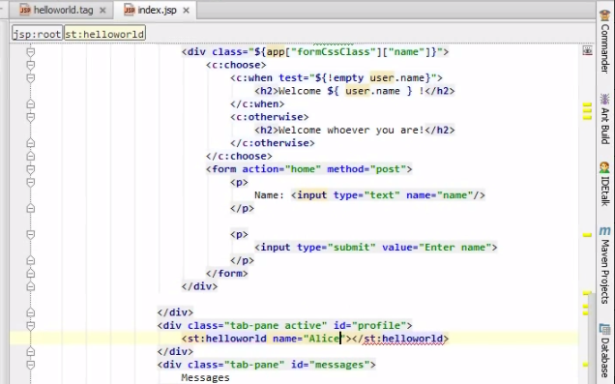

Result

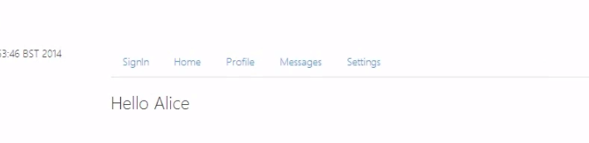

Or

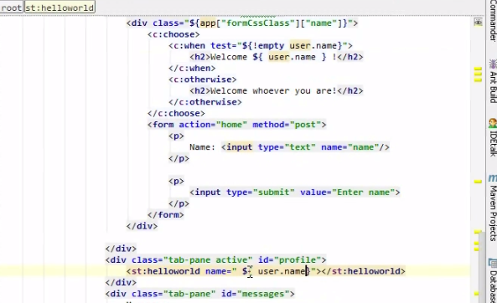

Result

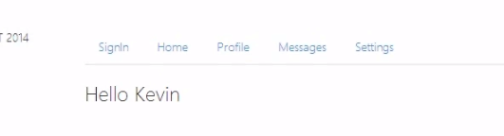

* create more complex tag

create profile.tag

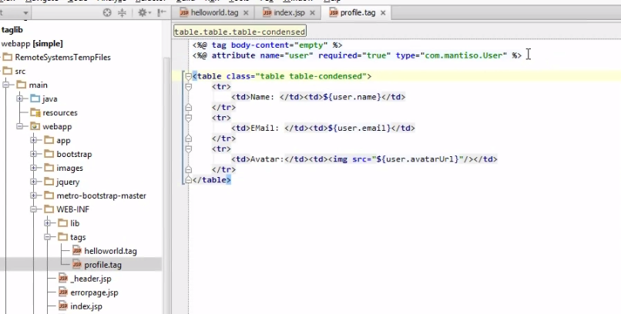

Adjust in index.html

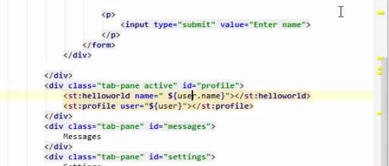

Result

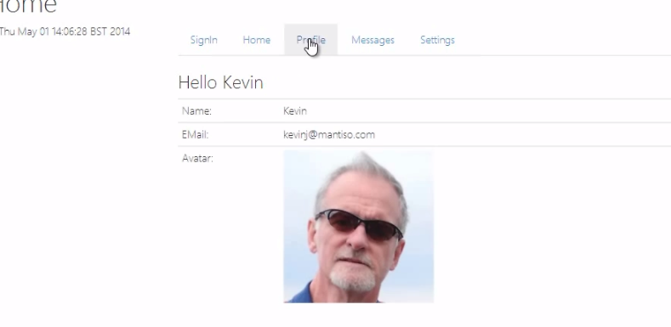

## Using jsp Fragments in Tag files

Scriptless mean is that the body of the tag can contain other html, it can ccontain other tag

Create class Todo

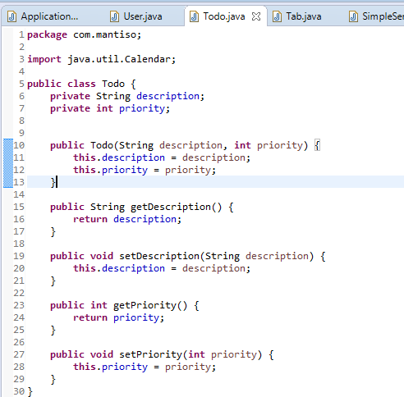

In class User

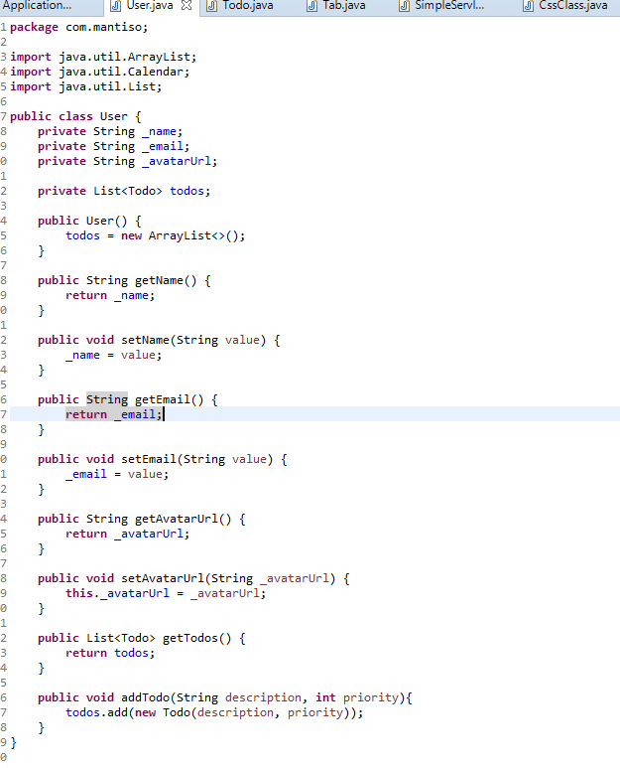

In class ControllerServlet

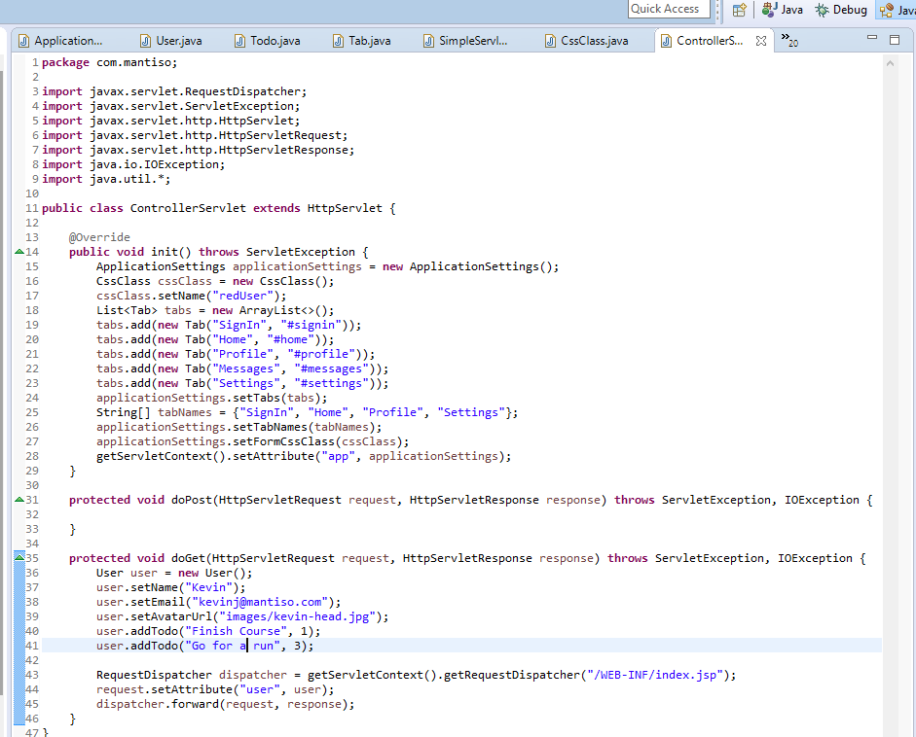

Create priority.tag

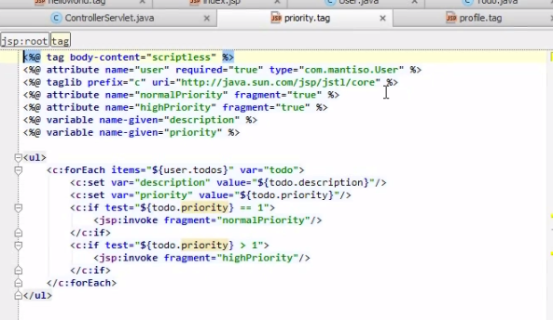

Excuse appropriate

fragment

Passing data outside ( index.jsp)

Passing fragment of html

Use other tag

Excuse other tag code (content fragment)

In file index.jsp

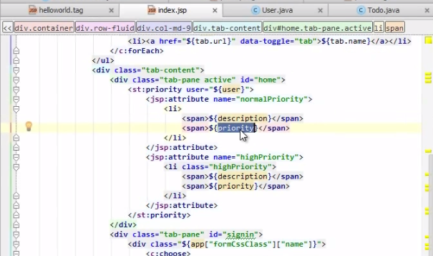

fragment

In class css

Result

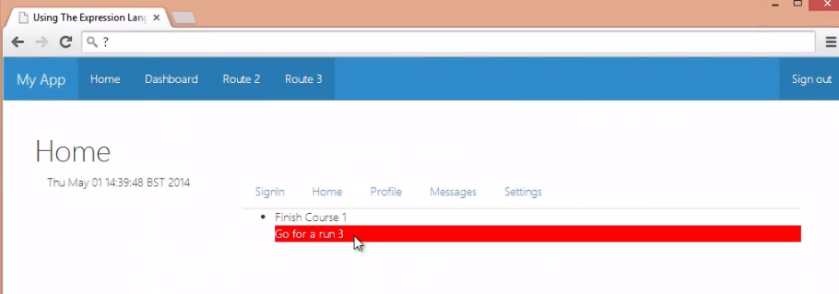

## Collecting tag in tag libraries

Create file taglib.tld

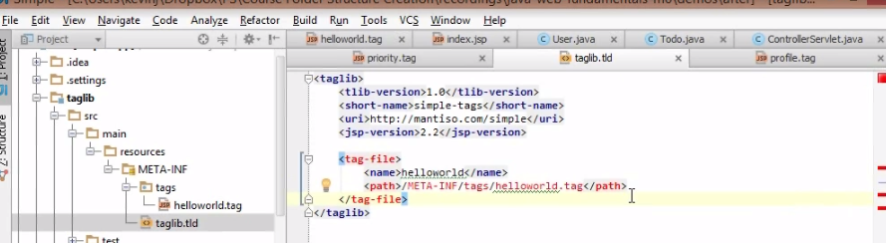

In file index.html

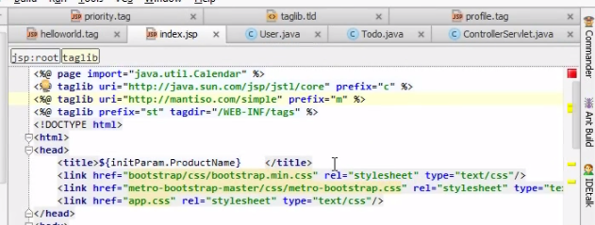

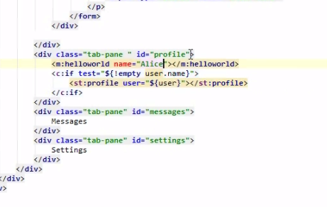

Result

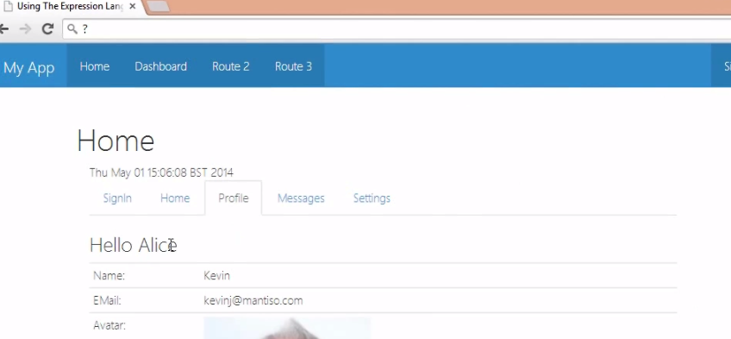

## Writing simple tags in java

We have class SimpleTagSupport

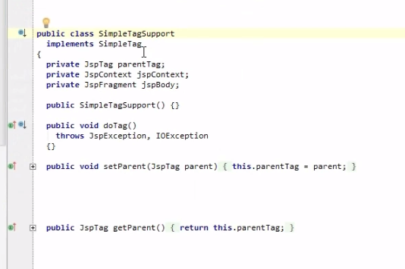

Create folder java package com.mantiso

And class Simple extends SimpleTagSupport

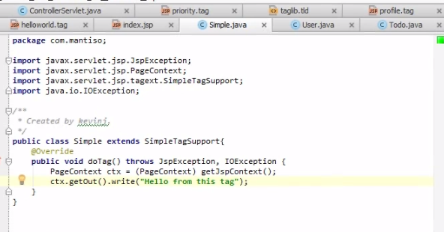

Add class in to taglib.tld

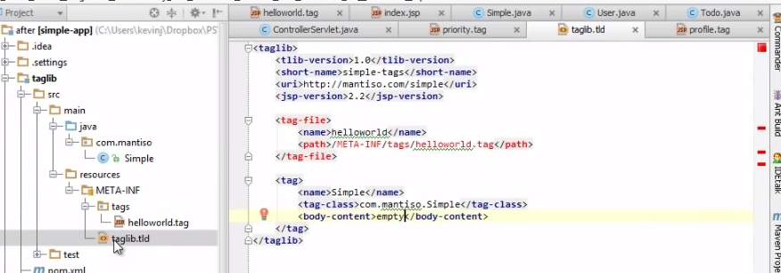

In file index.jsp

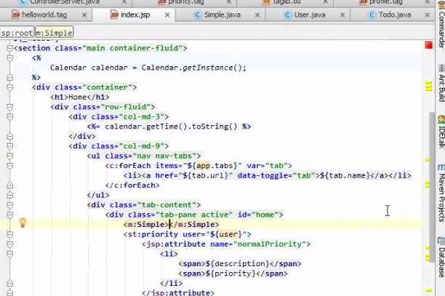

Result

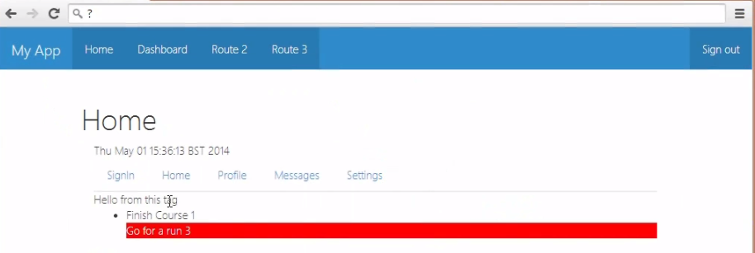

Create another tag

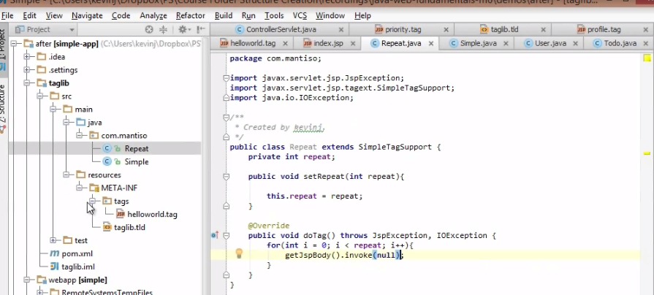

This will just write out that data onto the current output stream

Add information in taglib.tld

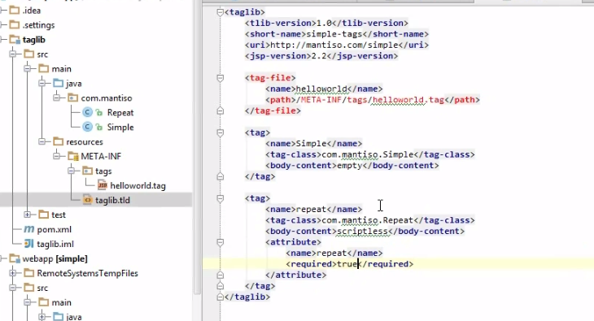

Infile index.jsp

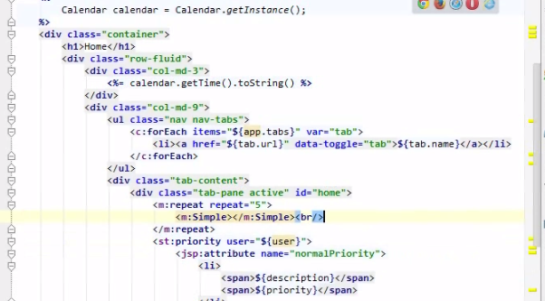

Result

